**1. Project Overview**

The ITI Examination System is designed to efficiently manage students, courses, instructors, and exams. It facilitates exam generation, question management, student responses, and report generation. This system aims to streamline the examination process and improve accuracy in grading.

**1.1 Objectives**

* Automate the examination process for institutions.
* Ensure accurate storage and retrieval of student performance data.
* Provide detailed reports on student and instructor activities.
* Enhance security and integrity in examination management.

**1.2 Technologies Used**

* **Database Management System**: Microsoft SQL Server
* **Backend**: SQL Stored Procedures
* **Frontend**: Web-based UI (optional integration)
* **Programming Languages**: SQL, C# (if applicable)
* **Reporting Tool**: SQL Reports

## **2. Database Schema**

The database consists of multiple tables, including:

* **Student**: Stores student details.
* **Instructor**: Stores instructor details.
* **Course**: Manages available courses.
* **Exam**: Contains exam details.
* **Questions**: Stores exam questions.
* **Choices**: Holds multiple-choice options.
* **Student Answers**: Tracks student responses.
* **Department**: Manages department information.
* **Exam Questions**: Links exams with questions.

### **2.1 Entity Relationship Diagram (ERD)**

### **2.2 Database Diagram**

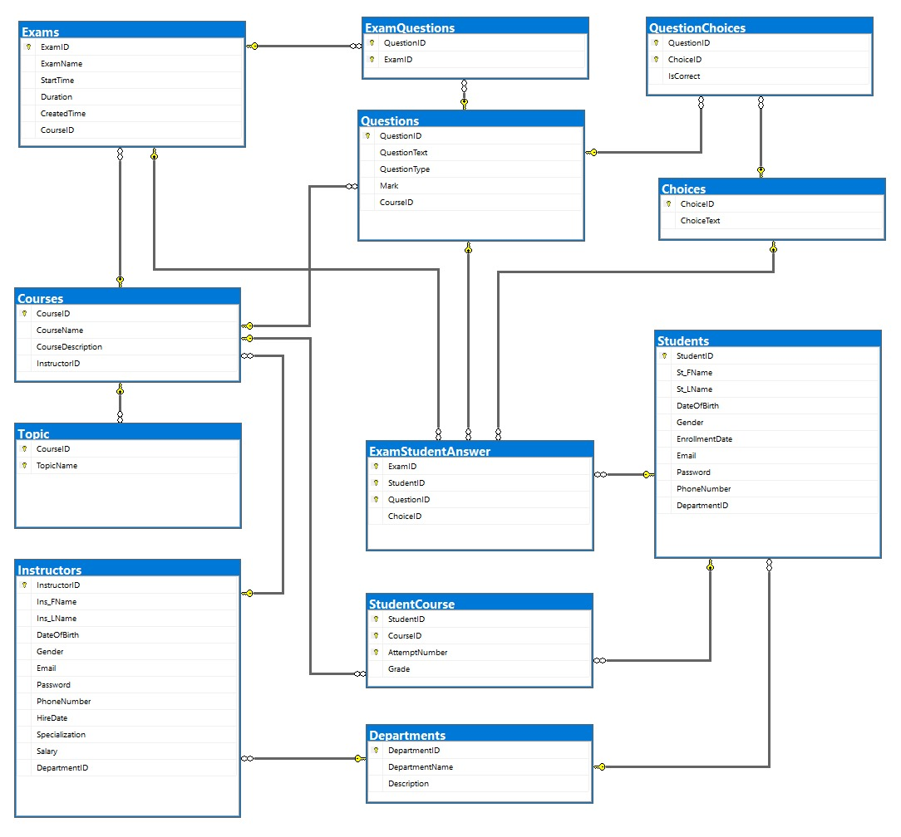

### **2.2 Database Mapping**

## **Stored Procedures**

## **Student Table**

## SP_AddNewStudent

* SP_DeleteStudent
* SP_UpdateStudent
* SP_SelectStudent
* SP_SelectAllStudentsWithDepartment

## **Instructors Table**

* SP_AddNewInstructor
* SP_DeleteInstructor
* SP_UpdateInstructor
* SP_SelectInstructor
* SP_SelectAllInstructorsWithDepartment

## **Departments Table**

* SP_AddNewDepartment
* SP_DeleteDepartment
* SP_UpdateDepartment
* SP_SelectDepartment
* SP_SelectAllDepartments

## **Courses Table**

* SP_AddNewCourse
* SP_DeleteCourse
* SP_UpdateCourse
* SP_SelectCourse
* SP_SelectAllCoursesWithInstructorAndDepartment

## **Topic Table**

* SP_AddNewTopic
* SP_DeleteTopic
* SP_UpdateTopic
* SP_SelectTopic

## **Questions Table**

* SP_AddNewQuestion
* SP_DeleteQuestion
* SP_UpdateQuestion
* SP_SelectQuestion

## **Choices Table**

* SP_AddNewChoice
* SP_DeleteChoice
* SP_UpdateChoice
* SP_SelectChoice
* SP_GetChoicesByQuestionId

## **StudentCourse Table**

* SP_EnrollStudentInCourse
* SP_DeleteStudentCourse
* SP_UpdateStudentCourse
* SP_SelectStudentCourse

## **QuestionChoices Table**

* SP_DeleteQuestionChoice
* SP_UpdateQuestionChoice
* SP_SelectQuestionChoice

## **Exams Table**

* SP_CreateExam
* SP_DeleteExam
* SP_UpdateExam
* SP_SelectExam

## **ExamStudentAnswer Table**

* SP_DeleteExamStudentAnswer
* SP_SelectExamStudentAnswer

## **ExamQuestions Table**

* SP_DeleteExamQuestion
* SP_SelectExamQuestion

## **Additional Procedures**

* **SP_CheckExamEligibility**

* **SP_AddStudentAnswers**A screenshot of a computer

  AI-generated content may be incorrect.
* **SP_StartExamA screenshot of a computer

  AI-generated content may be incorrect.**
* **SP_CalculateGrade**

## **4. Reports**

## Report that returns the students information according to Department No parameter.

## ﻿﻿Report that takes the student ID and returns the grades of the student in all courses.

## ﻿﻿Report that takes the instructor ID and returns the name of the courses that he teaches and the number of student per course

**

## ﻿﻿Report that takes course ID and returns its topics

## ﻿﻿Report that takes exam number and returns Questions in it

## Report that takes exam number and the student ID then returns the Questions in this exam with the student answers.

## **5. Setup & Usage Instructions**

### **5.1 Database Setup**

1. Install Microsoft SQL Server.
2. Execute the provided SQL scripts to create tables and stored procedures.
3. Insert initial data (departments, instructors, courses, students, etc.).

### **5.2 System Usage**

1. **Exam Creation**: Use SP_CreateExam to generate new exams.
2. **Adding Questions**: Use SP_AddNewQuestion to insert questions.
3. **Student Enrollment**: Enroll students using SP_EnrollStudentInCourse.
4. **Exam Execution**: Students can start exams using SP_StartExam.
5. **Grading**: Calculate student grades using SP_CalculateGrade.

### **5.3 Security & Maintenance**

* Regular database backups should be performed.
* User roles and permissions should be managed carefully to prevent unauthorized access.
* Stored procedures should be optimized for performance.

## **6. Conclusion**

The ITI Examination System offers an efficient and secure way to manage exams, student records, and instructor activities. The system ensures quick data retrieval, scalability, and enhanced exam security by leveraging stored procedures. Future enhancements may include an intuitive web interface and AI-based analytics for performance evaluation.

### **7. Future Enhancements**

* Web-based frontend for better accessibility.
* AI-driven exam analytics for performance evaluation.
* Integration with Learning Management Systems (LMS).
* Mobile-friendly examination interface for students.